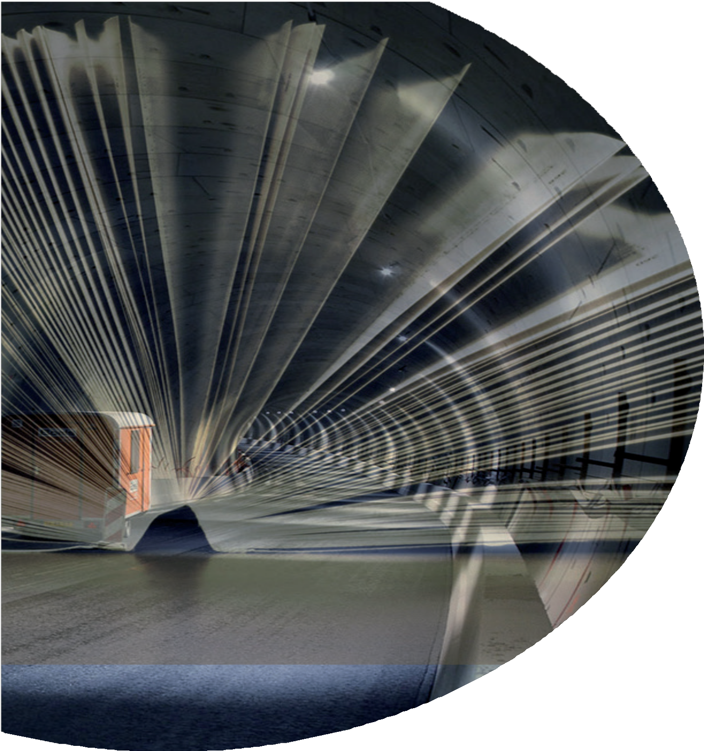

R701-4

Manual

'Know your tunnel'

Template and directions to make a tunnel specific manual

Manual
'Know your tunnel'
Template and directions to make a tunnel specific manual

Contents
- Explanatory notes 6
  - Background 6
  - Target group 6
  - Specifics 6
  - Manual in three parts 7
  - Preconditions 7
  - Practical examples 7
  - Use of this template and instructions for use 7
- Tunnel passport 8
- Tunnel management 13
- Tunnel timeline 18
Colophon 20


Manual in three parts
In order to establish structure in the relevant information and to simplify the management of the manual, the manual consists of three chapters:
1
Tunnel passport
2
Tunnel management
3
Tunnel timeline

1 | Tunnel passport | 8
1.1 | How the tunnel came to be | 8
 | 1.1.1 Introduction | 8
 | 1.1.2 Why the tunnel was built | 8
 | 1.1.3 Functions for the tunnel to fulfil | 8
 | 1.1.4 Construction history of the tunnel | 8
 | 1.1.5 Perception of the tunnel | 8
 | 1.1.6 Specific facts relating to the tunnel | 8
1.2 | Description of the structure | 9
 | 1.2.1 General | 9
 | 1.2.2 Route | 9
 | 1.2.3 Alignement | 9
 | 1.2.4 Ramps, exits, service roads | 9
 | 1.2.5 Service buildings | 9
 | 1.2.6 Safety design | 9
 | 1.2.7 Operation | 9
1.3 | Construction method | 10
 | 1.3.1 Tunnel | 10
 | 1.3.2 Foundations of the tunnel | 10
 | 1.3.3 Tunnel portals | 10
 | 1.3.4 Escape route | 11
 | 1.3.5 Ramps and service roads | 11
 | 1.3.6 Buildings | 11
 | 1.3.7 Management of water resources | 11
 | 1.3.8 Miscellaneous | 11
1.4 | Facilities | 11
 | 1.4.1 Technical installations in the tunnel | 11
 | 1.4.2 Technical installations relating to traffic | 11
 | 1.4.3 Operation/traffic-control centre | 11
 | 1.4.4 Third-party installations | 12
 | 1.4.5 Other facilities | 12
 | 1.4.6 Fire resistance | 12
1.5 | Certification | 12
1.6 | Permits | 12
1.7 | Other specifics | 12
1.8 | Appendices and reference materials | 12

- Tunnel management 13
  - Asset management 13
    - Vision, strategy and planning 13
    - Current situation 13
    - Starting points 13
    - Maintenance method 13
    - Information management and information systems 13
  - Tunnel management organisation 13
    - Position of tunnel management in the line organisation 13
    - Involvement of tunnel management in project 13
    - Tunnel manager and tunnel safety officer 13
    - Licensing authority 14
    - Processes and officials 14
    - Organisational structure 14
  - Safety philosophy 14
  - Safety organisation 14
    - Operation 14
    - Traffic and/or tunnel inspector 14
    - Emergency services 15
    - Other agencies involved 15
  - Maintenance strategy 15
    - Predictive maintenance (planned) 15
    - Corrective maintenance and failure definitions (malfunctions) 15
    - Inspections 15
    - Functional testing 15
    - Certification 15
    - Warranties 15
    - Reports and information provision 15
    - Operations during maintenance 16
  - Maintenance organisation 16
    - Tunnel management 16
    - Maintenance contractor 16
    - Other parties involved 16
  - Consultation structure 16
    - Operational consultation 16
    - Management consultation 16
    - Safety consultation 16
    - Other consultive forums 16
  - Financial management / financial streams 16
  - Appendices and reference materials 16

- Tunnel timeline 18
  - Origin 18
  - Overview of events and milestones 18
  - Event 1 18
    - Introduction 18
    - Background 18
    - General schedule 18
    - Scope 19
    - Approach taken 19
    - Documentation 19
    - Future issues 19
    - Other specifics 19
  - Appendices and reference materials 19

Explanatory notes

Background
The safety management plan and its underlying plans, the ‘as built’ dossier and technical construction dossier are a storehouses of information for road tunnels. however, a lot of information is often not specifically set down and thus exists only in the heads of those involved. This is often the case for specific starting points, design decisions, matters relating to how the work is performed, operational aspects, interesting facts, occurrences, etc. In addition, it is not always obvious where, or in which documents, specific information can be found and which people are involved (now or in the past).
This ‘Know your tunnel’ manual aims to collect such details that are not recorded elsewhere and present them in a compact overview. The manual does not aim to be a complete, exhaustive volume. It draws attention to the specifics, gives an overview of the tunnel in question and its history, and generally states how its operations and maintenance are organised. Its also aims to trigger the reader to 'dig deeper’ or look into other archive documents.
The starting point is to set out the issues that a diligent tunnel manager ought to be aware of. The manual thus also forms an overview that can be used as an initial source of information for workers at the start of their career within the management organisation.
In terms of format and content, this manual is intended for one specific road tunnel. however, it is also possible to design this manual to cover more than one tunnel within a single management organisation.

Target group
The target group for this document is the tunnel management organisation. The manual forms a refe- rence work for the team and its stakeholders, including the operator, the service provider/maintenance contractor, the project organisation team(s) for renovation projects and functional modifications, etc. In addition, the manual forms a good point of departure for people who are new to such organisations.
The manual is the property of the tunnel manager. The manager shall keep the manual up to date or outsource this process on a project-by-project basis as a separate activity under the terms of the contract.
The manual is not primarily intended for legal purposes, such as notification of the licensing authority, tunnel safety officer or the emergency services.

Specifics
The manual should focus on specifics. This covers a much wider scope than just tunnel safety. It relates to technical, administrative, organisational, procedural and environmental matters. The intention is definitely not to rewrite or, indeed, summarise the tunnel safety plan or the tunnel safety dossier. The manual is precisely intended for specifics that are not easy to find in the archives or tunnel safety dossier.
It should be possible, however, to read the manual as a stand-alone document in which specific information, taken from existing documents, has to be presented in summarised form. State where the more detailed information can be found.

Manual in three parts
In order to establish structure in the relevant information and to simplify the management of the manual, the manual consists of three chapters, these being:
- CHAPTER 1: The background, how and why the tunnel was built.
- CHAPTER 2: The management, how the tunnel is maintained.
- CHAPTER 3: The timeline, a record of what has been done and when this happened.

CHAPTER 1 is the least variable. CHAPTER 2 needs only be updated where there is a change in the manner of management, maintenance and operations, or if such a change implies new specifics. CHAPTER 3 is fleshed out with all relevant occurrences.
The following chapters give details for the information which needs to be considered. Not everything is applicable to each tunnel. In addition there are always certain specifics which are not included in this template. So sections may have to be added or removed as appropriate to suit specific needs and requirements.

Preconditions
For this manual, too, it is a fundamental point that it must be kept up to date. New specifics or events must be recorded in order to prevent them from merely remaining in people's heads, which would counteract the purpose of the manual. This demands discipline and the identification of a document owner.
In order to keep the total scope of the manual manageable, it is important that the document is limited to around 100 pages at most. The breakdown shown below can be used as a guideline:
- Chapter 1: approx. 20 pages.
- Chapter 2: approx. 40 pages.
- Chapter 3: max. approx. 40 pages, depending on the age of the tunnel or specific issues.

Practical examples
This 'Know your Tunnel’ manual has been created with the assistance of a number of tunnel manage- ment organisations. Since the start of development of this format it has been applied to the Maas- tunnel (in Rotterdam, at the time of its renovation) and for the tunnels in the City of The hague (one manual for all tunnels in the city). The manual for the Kiltunnel (Dordrecht) will be compiled during its refurbishment. Where required, additional information on the use and completion of this 'Know your Tunnel’ manual can be obtained from these tunnel management organisation.

Use of this template and instructions for use
This document lists the basic contents for the 'Know your Tunnel’ manual in three chapters. The follo- wing sections are set out in this way. For each section an explanation of how to use this template is given.



Tunnel passport

How the tunnel came to be

Introduction
This should be a short introduction outlining the context behind the tunnel with a description that includes at least the following points:
      - Where is the tunnel located?
      - Who is the asset owner?
      - Is it a road, rail, tram or other sort of tunnel?

Why the tunnel was built
Describe the original reason for building the tunnel. Was it a new underwater crossing? Or was it, perhaps, a land tunnel designed to improve the quality of life in an urban area? In addition to why the tunnel was built, describe the context at the time in which this came about.
      - Who was the instigator and who was the contractor?
      - What were the established starting points, preconditions and specifics?
      - What relevant and essential decisions were made?
      - Which people (including management and maintenance) and what resources were made available?

Functions for the tunnel to fulfil
Describe the envisaged functions of the tunnel. Was it a road or rail tunnel? Does it have special provisions in relation to slow-moving traffic, cyclists and pedestrians? Does the tunnel still have a function to fulfil in relation to providing a duct for utilities and services (main transportation pipelines for gas, electricity or water)? Does the tunnel still have additional functions due to its situation in, for instance, an urban environment (connecting areas of a city that are otherwise divided, reclaiming land for sports fields on the roof of the tunnel, etc.)?

Construction history of the tunnel
Provide a historical perspective on the construction of the tunnel. When was the tunnel built? has it subsequently been refurbished and/or modified and/or enlarged? This applies solely to the phase of the initial building of the tunnel. an overview of historical events is included in CHAPTER 3 of this manual.

Perception of the tunnel
Describe how the tunnel is perceived by the users, local residents and other stakeholders. Is the per- ception ‘friendly’ or is it actually perceived to be a threat? Is it a comfort or does it cause problems? Is it simple or complex in its operation? Does it have plenty of supporters or does it face opposition?

Specific facts relating to the tunnel
Give a brief description of the specific facts relating to the tunnel. Think about the mode of construc- tion, the facilities offered, the organisation, the situation or other such matters. In particular design decisions, cost savings, departures from legislation, differences/specifics in terms of use, possible scheduled monument status or industrial heritage, etc. are relevant for inclusion in this section.

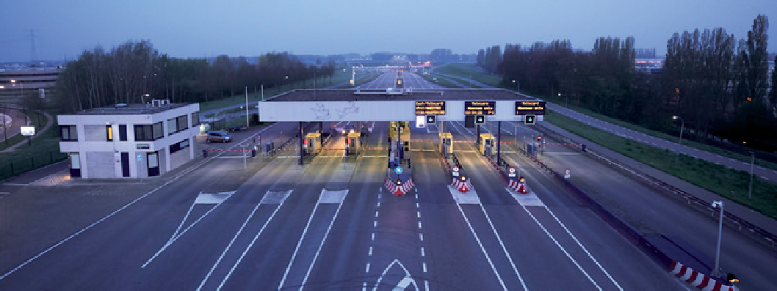
Figuur 1.1 / There is an of fice building next to the toll plaza for the eastern entrance to the Kiltunnel. (Photo: Vincent Basler)

Description of the structure

General
Describe the tunnel structure and its particular features, such as the number of tubes, length, height, width, number of lanes, presence of a central tunnel tube, etc. also describe specific details such as soil condition, use of the tunnel roof as part of the urban environment, etc.

Route
Describe the route of which the tunnel forms a part. also specify the type of road or rail connection concerned and what this means for the tunnel.

Alignement
Describe the alignment of the tunnel. Where necessary, insert a sketch showing the length of the tunnel and a cross-section. enter the position of such things as service buildings, cisterns, extinguishing reservoirs, etc.

Ramps, exits, service roads
Give a brief description of ramps, exits and service roads. Where necessary, specify any departures from legislation (e.g. the '10-seconds rule'), use of service roads, etc.

Service buildings
Describe the location/situation and accessibility of the service buildings. This should also include specific details in relation to the functions and use. For instance, specify whether a service building is configured for functions such as local operation, accommodation of the service provider/maintenance contractor, office space, etc.

Safety design
Describe the overall safety design of the tunnel. how is the safety of the user fundamentally guaranteed? Give a brief description of the escape route from the location of the user, via one or more safe spaces up to and including assembly area(s). Where necessary or possible, clarify this with a drawing. also describe the considerations behind the creation of the safe space (does it have positive pressure or not?).
In addition, describe how the emergency services can access the structure (e.g. approaching it from one side in particular or both sides, with water tender or rapid-intervention vehicle, etc.).

Operation
Describe where and by whom the tunnel is operated and monitored. Indicate whether there is a specific control centre for this tunnel, or that it is operated from a control centre controlling more than one tunnel and/or other structures. Indicate any specific details such as specific operating systems, camera systems, personnel matters (within the organisation or out-sourced), etc.

Construction method

Tunnel
Describe the method of construction of the tunnel. Is it a bored tunnel? Is it built using the ‘cut and cover’ method? Does it consist of tunnel segments making up an immersed tube? Or is it built using another method? how are the joints sealed (including closure joint) and how are the central tunnel tube or cross-passages constructed? Does the top of the tunnel need to be covered?
Describe also the specifics and imperfections in construction, such as:
      - Presence of flood defences.
      - Presence of check dams.
      - Special sheet-piling structures, including anchor piling.
      - Remaining sheet-piling walls.
      - Remaining support structures, form work, etc.
      - Intentional leakage to prevent freezing of joints.
      - Specifics relating to walls, e.g. in terms of reflective properties (tiling, cladding, coating).
      - environmentally hazardous materials used (asbestos, chromium-6, PCBs).
      - alterations compared with the original design (capacity and number of water sumps, extra drains, extra pump capacity, etc.).

Foundations of the tunnel
Describe the foundation system used in the tunnel. Is the tunnel built on a foundation bed, anchor piles or otherwise?

Tunnel portals
Describe what the tunnel portals look like, how they were built and what sort of foundations they were built on. are there other specifics relating to the design, architecture, permits, interaction with road users or the environment, or otherwise? are there smoke barriers? are there any anti-blinding measures and, if so, what form do these take?
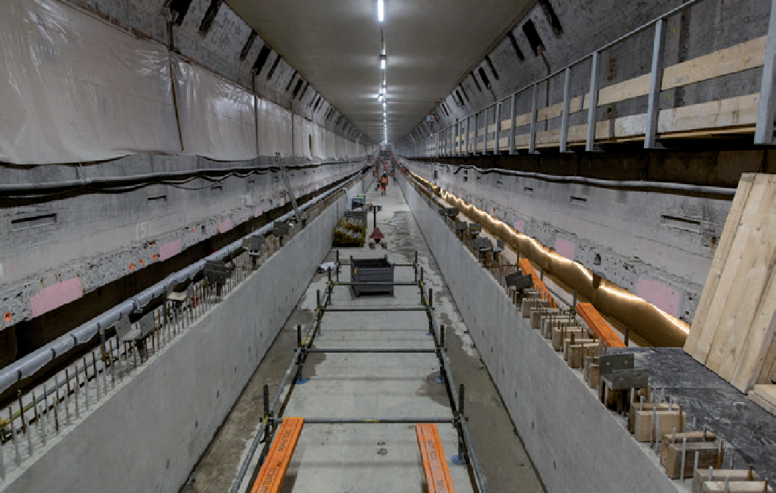
Figuur 1.3 / The Maastunnel in Rotterdam was thoroughly renovated in 2017-2019. The floors have been replaced and many new tunnel safety installations have been added. (Photo: Carel van Hees)

Escape route
Describe the escape route (including safe spaces). also insert any other specific information in relation to escape doors and/or exit doors.

Ramps and service roads
Describe how the access roads and service roads were built (pit with sheet-piling walls, anchor piling, facing walls, check dams, grout anchors, etc.) and any specifics relating to these, such as the access- road heating at the heinenoordtunnel.

Buildings
Describe the construction and specifics of the service buildings and any other buildings and/or spaces related to the tunnel, including alterations during construction (moving or changing the control centre, change to the configuration of technical rooms, increase of pumping capacity, etc.). Include also aspects such as architecture, sustainability, use of special materials, etc.

Management of water resources
Describe how the management of water resources is organised, both inside and outside the tunnel. Consider aspects such as:
      - Inside the tunnel
        - Water sumps, including the separation of clean and waste water (first flush).
        - Guttering, drains and sewerage.
        - Drainage system (waste water and/or surface water).
        - Siphon structure between tunnel tubes.
        - Sand trap.
        - Basis for calculating the dimensions of the buffer capacity.

      - Outside the tunnel
        - Drainage system.
        - Retention basin(s).
        - Gravel traps.
        - Presence of springs

Miscellaneous
Describe other specifics in relation to the method of construction and current situation at the tunnel. Consider, for instance, specifics in relation to structures in the immediate vicinity or on top of the tun- nel, the presence of an emergency pool (water source) to use for extinguishing a fire, etc. also include established facts in relation to damage during construction, any deformation, degradation, damage caused during use, leakages, subsidence, a particular cable duct, etc.

Facilities

Technical installations in the tunnel
Give a brief description of the technical installations in the tunnel. Make this short and to the point, for instance in the form of table. Then show any specifics for each installation or part.

Technical installations relating to traffic
Give a brief description of the technical installations in the tunnel relating to traffic. Make this short and to the point, for instance in the form of table. Then show any specifics for each installation or part.

Operation/traffic-control centre
Describe the method of operation and the centre's location. Specify the technical installations and the functionality that is available, both centrally and locally.

Third-party installations
Describe which third-party installations are present in the tunnel, service buildings or technical rooms. Consider, for instance, installations for mobile telephony providers, utilities companies (connections for electricity, gas, water, telephony, internet, fibre-optics), C2000 systems, etc.

Other facilities
Describe any other special facilities present. Consider, for instance, lifts, escalators, systems for monitoring pedestrians, cyclists, slow-moving traffic, etc. also describe any other specifics in relation to the facilities. This might include temporary facilities, systems that are not (or not fully) functioning, specific opportunities and/or restrictions, etc.

Fire resistance
Describe the fire resistance of the tunnel and explain briefly:
      - Which fire curve is in use (hydrocarbon curve, RWS fire curve, etc.)?
      - has heat-resistant cladding been used and, if so, at which points of the tunnel and in what way is it applied (cast in-situ, shielding added at a later date, etc.)?
      - have extra measures been taken/extra facilities been included in the context of fire resistance?

Certification
Give a brief summary of applicable certification. Consider, for instance, fire-extinguishing systems, intrusion and fire detection in the service buildings and service passage, etc.

Permits
List any applicable permits here. Consider, for instance, the opening permit, use permits, water- discharge permits, etc. Briefly list any specific conditions mentioned in the permits.

Other specifics
are there any other specifics? For instance in relation to the stakeholders involved, structural aspects, design decisions, saving measures, defects. Describe these aspects here as a record that others may consult.

Appendices and reference materials
List the documents and dossiers relevant to this chapter, including the source of the information and references. Consider any relevant documentation, such as the tunnel safety dossier, tunnel archive, tunnel safety plan and/or safety management plan.
In case this part of the 'Know your tunnel’ manual has specific in-depth appendices, they may be summarised here.



Tunnel management

Asset management

Vision, strategy and planning
Give a brief summary of the vision and strategy in relation to the maintenance of the tunnel. are those specific to the tunnel, or is it the same as the management vision of another area of the management organisation? how is the planning of the asset management, administration and maintenance coordinated?

Current situation
Describe the current situation in relation to the management of the tunnel. are there any other organisa- tional aspects in development? Is everything safeguarded? Is work ongoing on implementation, improve- ments and/or alterations? Is the ambition clear and has it been achieved, or is this still open-ended?

Starting points
Describe the specific starting points for the management of the tunnel. Is management performance- driven? Is management linked to budgets? What are the opportunities and threats in relation to scheduled and unscheduled tunnel closures, etc.?

Maintenance method
Describe which method is used to maintain the tunnel. Is there a fixed method (RCM, VDM, ProBo, etc.)? To what extent is this method used and what specifics is it subject to?

Information management and information systems
Describe how information is dealt with. Who controls which information? Who provides the information? how is the standard of the information safeguarded? Which information systems and/or maintenance management systems are in use and who is responsible for them?

Tunnel management organisation

Position of tunnel management in the line organisation
Give a brief description of the tunnel management organisation and, in particular, its position in the line organisation. Who are the officials? What does the manager him/herself do and what does he/ she leave to other departments, divisions or parties in the market? Is management kept completely in-house, or is a managing agent contract in use/are management tasks otherwise outsourced?

Involvement of tunnel management in project
Describe how the tunnel management organisation is involved with projects. This relates to new- build projects, renovation projects and functional changes. explain how the link between projects and management is organised and how responsibilities are allocated.

Tunnel manager and tunnel safety officer
The tunnel legislation demands that at least two roles are created, these being the role of tunnel manager and that of the tunnel safety officer. Describe which officials fulfil these roles and how the roles are anchored in the organisation.

Licensing authority
Describe briefly which licensing authority is responsible for the tunnel. In doing so, state whether the licensing authority outsources activities to an environmental agency and/or uses consultants (external or otherwise).

Processes and officials
The management of a tunnel is carried out by a number of officials. They adhere to a number of processes including drafting maintenance schedules, change management, troubleshooting, financial planning, etc. Describe briefly the processes that have been designed and who (which official) is responsible in each case.

Organisational structure
Describe the organisational structure. If possible, please include an organisation chart. In that chart, show how the tunnel management organisation is structured and how this meshes with the line organisation.

Safety philosophy
Describe in summary the safety philosophy for the tunnel. In addition to the safety and security of users (tunnel safety), consider also the security of information, the security of the structure and the safeguarding of safety and security as a whole, including health and safety in the workplace ('arboveilig- heid'). In addition to structural elements, consider also cultural elements.

Safety organisation

Operation
Describe briefly the operator and its operational philosophy. Is the tunnel continuously monitored and observed, or is action taken reactively, in response to triggers? are operators responsible for just a single tunnel or multiple tunnels? are operators responsible for both operations and monitoring, or are they also the 'director’ during incidents and emergencies? Besides the basic duties, does the operator have any other duties, such as traffic management or toll collection?

Traffic and/or tunnel inspector
Describe the role of the traffic and/or tunnel inspector and how this is allocated. What is the inspector's role and what are his/her responsibilities and his/her remit? how does the interaction with the operator and the manager take place? Is this done round the clock (24/7) or on a call-out basis?
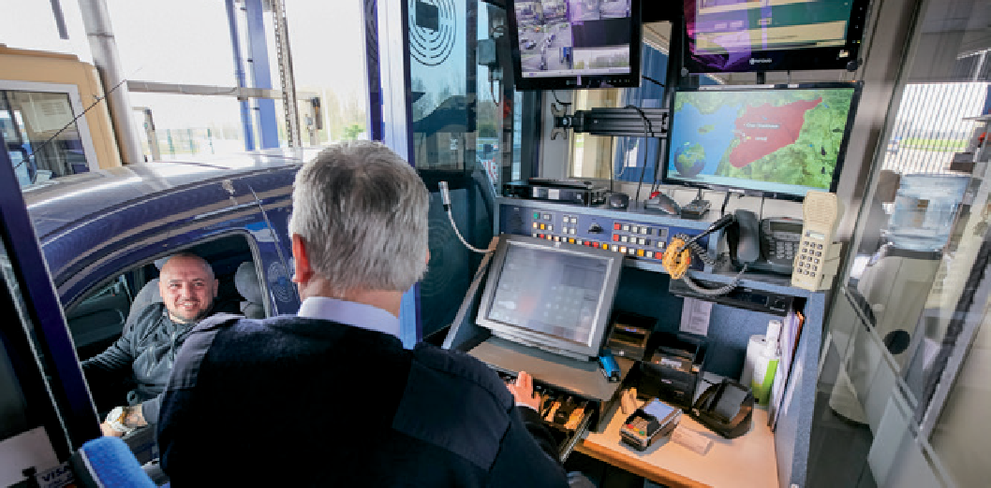
Figuur 2.1 / The toll of ficials of the Kiltunnel have a control room with which they can oversee the entire tunnel and intervene where necessary. (Photo: Vincent Basler)

Emergency services
State here the emergency services that are responsible for taking action to streamline operations during incidents and emergencies. Where more than one emergency service is involved, specify how duties and roles are divided.

Other agencies involved
Describe any other agencies involved. This may, for instance, include the licensing authority (including 6-yearly inspection), the water authority, the mains-water supplier, freight/transport companies, industrial partners, etc. Consider also organisations such as utilities companies, which may make use of the tunnel as a corridor for service ducts, etc.

Maintenance strategy

Predictive maintenance (planned)
Describe in summary how preventive maintenance and scheduled maintenance are prepared, carried out and reported. how are maintenance windows reserved and which parties does this involve? What are the windows of workable hours? Is this restricted to nighttime closure for work, or can this also be done during the day?

Corrective maintenance and failure definitions (malfunctions)
Describe in summary the process to be followed for corrective maintenance. how does the process of identifying, reporting, analysing, resolving and clearing malfunctions work? Is there a procedure for analysis of malfunctions, problem management (repetitive malfunctions and/or sizeable, complex malfunctions)? Is a distinction made between running repairs and full repairs? Describe the minimum safety level in the event of malfunctions (expressed in the form of failure definitions), including compensatory and/or risk-mitigating measures and tolerance deadlines.

Inspections
Describe which inspections are carried out and why. This relates to aspects such as statutory mandatory inspection (e.g. regular servicing of fire-extinguishing equipment and fire alarm systems), status inspec- tions, specific technical inspections in the event of malfunctions and/or damage, general inspection, etc. also describe the process for following-up the results of inspections.

Functional testing
Describe the regular functional testing that is carried out. In doing so, describe briefly the aim, the approach taken and the frequency of such testing. Consider, for instance, functional testing of functions critical to safety, operating conditions (emergency operation, operation in the event of evacuation), switching to ventilation, positive pressure, etc.

Certification
Describe the systems, components and/or parts of the structure that have been inspected and certified. State which certificates need re-certification at regular intervals. This includes fire-extinguishing equip- ment, fire alarm systems and burglar alarm systems, as well as environmentally-harmful substances or materials, sample taking, etc.

Warranties
Describe briefly the warranties that are applicable and where the details in relation to duration, conditions, restrictions, etc. can be found. More often than not, this will be a reference to a register of warranties or warranty database. Describe any specifics in relation to warranties.

Reports and information provision
Briefly describe the process for reporting and providing information, both internally and with parties in the market, licensing authority and stakeholders.

Operations during maintenance
Describe the procedure for operation and monitoring during maintenance. Who is responsible for it and who carries it out? Is that the normal operator under the responsibility of the tunnel manager, or does responsibility pass to the maintenance contractor? If so, how is the transfer process organised?

Maintenance organisation

Tunnel management
Describe the role of the tunnel management organisation in respect of day-to-day maintenance and long-term maintenance. Specify what the tunnel management organisation does itself and what it outsources to the market and/or other divisions within the organisation.

Maintenance contractor
Describe the organisation, responsibility and approach of the maintenance contractor. What is its share of the work, approach and responsibilities? how is the organisation structured and what is its connection to the tunnel management organisation?

Other parties involved
Describe any other parties involved in the maintenance of the tunnel and their organisation structure. This may include specific specialist companies, suppliers or consultants.

Consultation structure

Operational consultation
Describe the operational consultations that are held between the operational organisation and the third parties from the market where applicable, including the maintenance contractor, specialists and suppliers.

Management consultation
Describe the internal management consultation structure. This may include several consultation meetings at various levels within the organisation (tactical, strategic, operational).

Safety consultation
Describe the safety consultation between such parties as the management organisation, tunnel safety officer and the relevant emergency services.

Other consultive forums
Describe any other relevant consultation structures.

Financial management / financial streams
Describe in summary how the financial management and/or financial streams in relation to the con- struction, management and renovation of the tunnel are arranged. Describe how the required financial cover is allocated and realised. Is this a product of the normal management process or of regular inspections, replacement and renovation specifications, investment plans, etc.? Show the difference between the financial streams for CaPeX and OPeX. explain the financial justification (reporting) that is used and the tender procedure rules that are applicable.

Appendices and reference materials
List the documents and dossiers relevant to this chapter, including the source of the information and references. Consider any relevant documentation, such as the tunnel safety dossier, tunnel archive, tunnel safety plan and/or safety management plan.
Where this part of the 'Know your Tunnel’ manual has specific in-depth appendices, they may be summarised here.

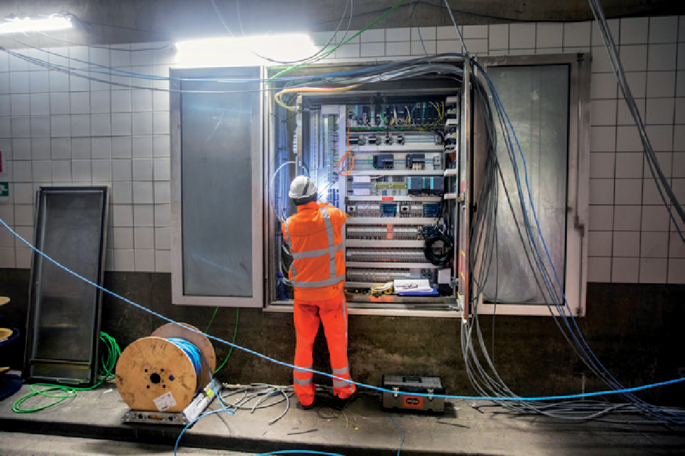
Figuur 2.2 / In 2019, the Koningstunnel in The Hague was due for major maintenance. Almost all existing installations and cabling have been replaced and additional installations have been installed to meet the safety requirements. (Photo: Frank Jansen)



Tunnel timeline

Origin
Describe background to the construction of the tunnel. State the year that construction on the tunnel started, how long it took to build the tunnel and what specifics are relevant to this. avoid stating the same information as in CHAPTER 1 of this manual. Stick to the historical facts surrounding the origins of the tunnel that are still relevant today (time, context, the situation the tunnel was built to address, financial information, starting points, choices relating to technical aspects, design choices, restrictions, setbacks, damage, etc.).

Overview of events and milestones
Insert a timeline for the tunnel. Begin with the start of construction (origin) and end at the present day. Show this either visually or in the form of a table. The aim of this section is to present a quick overview of relevant events.
Show relevant milestones on the time line, including:
- Refurbishments.
- Significant incidents and emergencies.
- Relevant damage that occurred and the repairs that were made.
- Relevant changes to legislation.
- Relevant changes to the organisation(s), the control structure, the stakeholders involved.
- Other relevant events , e.g. obtaining monument status, changes in functionality, changes in the permitted class of hazardous materials, etc.
as the service life of the tunnel increases the number of milestones/events increases, too. If so, select the relevant milestones to keep the list manageable. The selection criteria are relevance and specifics.

Event 1
In this section, describe an event on the time line, starting with the most recent. Copy this section in its entirety for each event/milestone. The classification into sub-sections (and their names) shown below is merely indicative. Where necessary, it may be adapted to individual requirements.

Introduction
Give a summary of the event in question, i.e. what happened, when did it happen, etc.

Background
Describe the background to the event. Why was the event necessary, or why did it occur?

General schedule
Give a general description of the planning schedule/lead time for the event. For instance, this might include relevance in terms of refurbishment projects or projects relating to functional changes.

Scope
Describe the scope of the project, incident or emergency.

Approach taken
Describe the approach taken when a project was carried out. What were the individual phases into which the work was divided and what working method was used to keep disruption to a minimum (e.g. working at night only, complete closure, one tunnel tube at a time, etc.)?

Documentation
Describe the documentation showing that all changes/refurbished components comply with the relevant requirements and which tests, verifications, validations and certifications were completed. Were any inconsistencies identified and what is the procedure for dealing with these in the operations phase?

Future issues
Describe any possible future issues revealed during refurbishments. Consider aspects such as:
      - Which items were not renovated?
      - What replacements still need to be made?
      - Which environmentally hazardous materials (asbestos, chromium trioxide, PCBs, etc.) have been removed from which locations, and for which materials/which locations is this not (yet) the case?
      - Which certifications, inspections, measurements, samples and other controls does the tunnel manager need to take into account in the near future?
      - Which methods have worked well and which less so?

This may, on the one hand, constitute items on a 'to do’ list for future reference. But, primarily, this will involve ‘lessons learned’ for use in future projects.

Other specifics
Describe any other specifics in relation to the event. This may include actual facts that are relevant for future reference, but also unexpected aspects that came to light during the events, lessons learned, points for improvement, etc.

Appendices and reference materials
List the documents and dossiers relevant to this chapter, including the source of the information and references. Consider any relevant documentation, such as the tunnel safety dossier, tunnel archive, tunnel safety plan and/or safety management plan.
Where this part of the 'Know your Tunnel’ manual has specific in-depth appendices, they may be summarised here.

Colophon
Publisher
Netherlands knowledge centre for underground construction and underground space (COB).




and underground space

Netherlands
knowledge centre for underground construction

Van der Burghweg 1, 2628 CS Delft • building De Bouwcampus P.O.Box 582, 2600 aN Delft
+31 85 4862 410 • info@cob.nl • www.cob.nl
Authors
- arie Bras (Kiltunnel, chair of working group)
- harry de haan (elumint/Kiltunnel, chair of working group)
- hans Janssens (COB/DON Bureau, secretary)
- Diederik van Zanten (City of Rotterdam)
- Wilbert Jansen (City of Rotterdam)
- Mello Lindner (Sweco/Maastunnel)
- erik Meijs (City of The hague)
- Tom Versluijs (City of The hague)
Editing and design
Marije Nieuwenhuizen, COB/Gryffin
Publication date
31 maart 2020
Cover
Rotterdamsebaan during the 'Dag van de Bouw' event in 2019, by etienne Muis via Flickr
Download
This publication is freely available at www.cob.nl/kennisbank.
Reuse
Texts from this publication may be freely reproduced, provided that the source is clearly stated. For reuse of figures and photos, you must first obtain permission from the indicated source holder. If no source is stated, this publication will be considered as the source.

The COB and those who contributed to this publication have taken the greatest possible care in compiling the publication. However, it should not be excluded that errors or omissions may occur. Any use of this publication and data from it is entirely at the user's own risk. The COB, also for the benefit of those who contributed to this publication, excludes any liability for damage that may arise from the use of this publication and the data contained therein, unless the damage may result from intent or gross negligence on the part of the COB and/or those who contributed to this publication.






Manual
'Know your tunnel'
Template and directions to make a tunnel specific manual

For tunnels, a lot of information is contained in (legally required) plans, but there is also a lot of knowledge that resides only in the heads of those involved. This often concerns specific starting points, design decisions, incidents, etc. Such details can be bundled in a manual 'Know your tunnel' by means of this template and directions.
The starting point of a 'Know your tunnel' manual is to record what a diligent tunnel manager ought to be aware of. The manual mainly describes details that are not recorded anywhere else. The aim is not to give a complete, exhaustive overview but to draw attention to the specifics, give an outline of the tunnel and its history, and generally state how its operations and mainte- nance are organised. Its also aims to trigger the reader to 'dig deeper’ or look into other archive documents.
a 'Know your tunnel' manual is the property of the tunnel manager. The manual forms a refe- rence work for the team and its stakeholders, including the operator, the service provider/ maintenance contractor, the project organisation team(s) for renovation projects and functional modifications, etc. In addition, the manual is a good point of departure for people who are new to such organisations. The manual is not primarily intended for
legal purposes, such as notification of the licensing authority, tunnel safety officer or the emergency services.
In terms of format and content, this manual is intended for one specific road tunnel. however, it is also possible to design this manual to cover more
than one tunnel within a single management organisation.

Netherlands
knowledge centre for underground construction
and underground space

